Step 1

Generated 50 input spike trains into two sets. A a vector of initial values of the synaptic strength and a vector of corresponding synaptic conductances.

Step 2

Simulated a leaky integrate-and-fire neuron receiving time-varying synaptic input, then applied STDP to show how spike timing causes some synapses to strengthen and others to weaken.

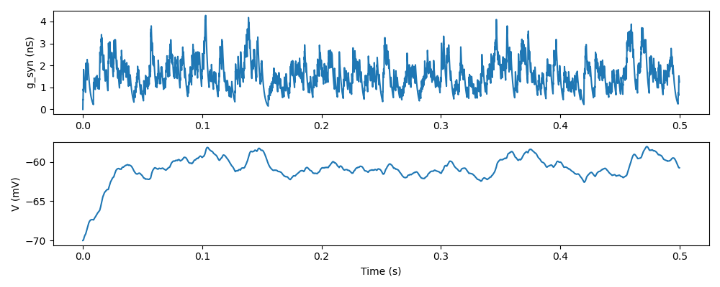

The top panel displays the **synaptic conductance** Gsyn(t), which fluctuates due to the incoming spikes.

The bottom panel shows the **membrane potential** V(t), which responds to synaptic input and leak currents, with fluctuations around the resting potential.

Step 3

Repeated the simulation with the same input spike trains but disabled synaptic plasticity, so the synaptic strengths remained constant throughout. This compares the neuron's behavior with and without STDP, isolating the effect of plasticity on synaptic competition and selectivity.

This competitive adjustment sharpened the neuron’s tuning to the correlated input pattern. In contrast, without STDP, the neuron's response remained more uniform across all inputs, showing no clear preference or selectivity.

The plots showed a random pattern of synaptic strengths, and generally fell into the range from 0.45 to 0.55 nS.

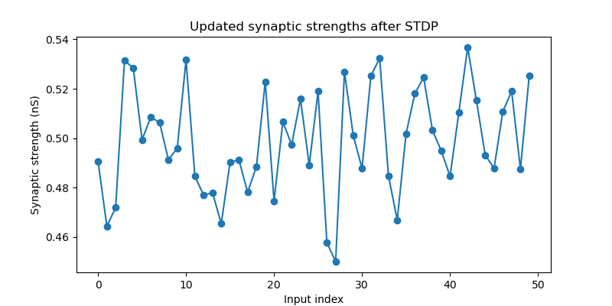

Step 4

Repeat 1-3 for 200 trials, but only producing plots every 20 trials

More trials done confirmed the conclusion in the last step.

The last figure shows the mean synaptic strengths of the two sets of 25 inputs as a function of trial number. When one group of inputs (Subset A) fires consistently just before the postsynaptic neuron, while the other group (Subset B) fires just after.

Both blue (A) and orange (B) wiggle around the 0.50 nS baseline, but on average, the blue curve drifts upward (to ≈0.51 nS) and the orange drifts downward (to ≈0.49 nS)

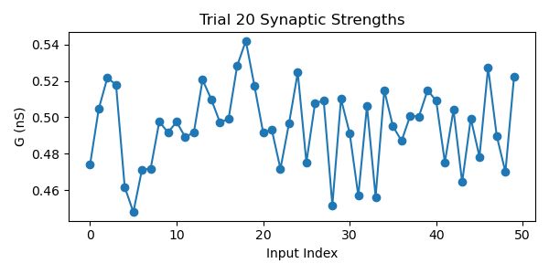

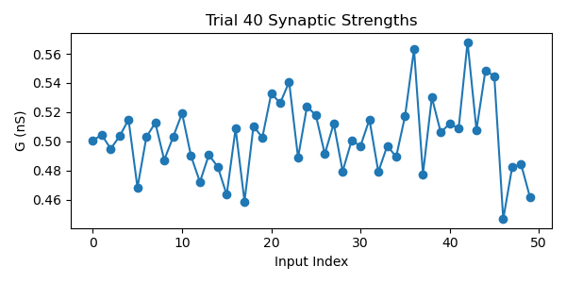

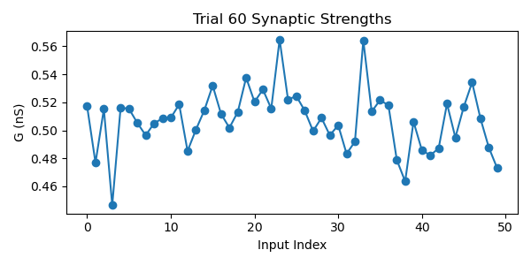

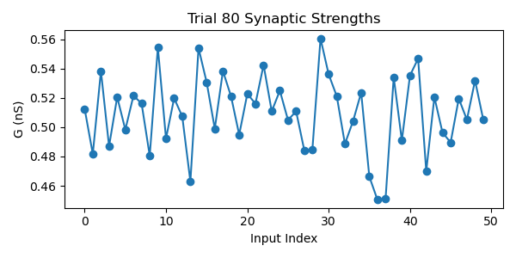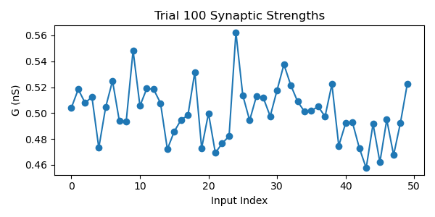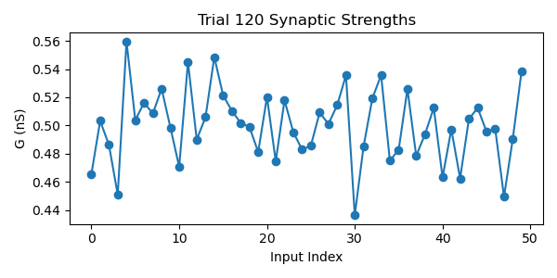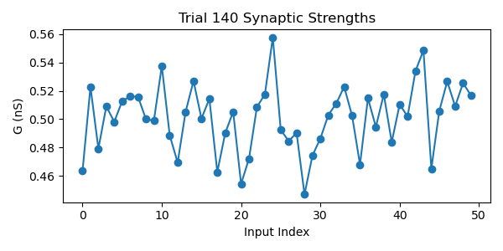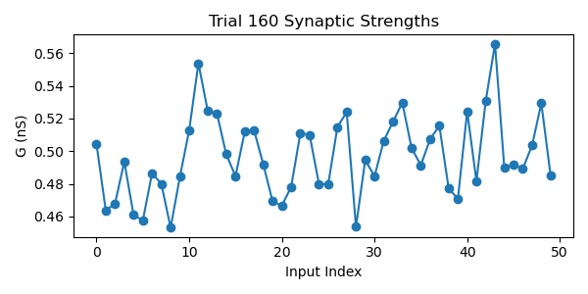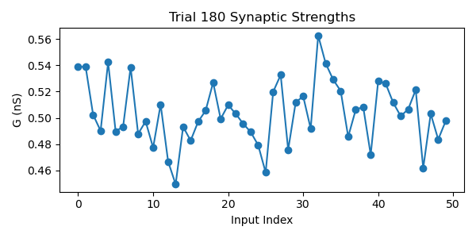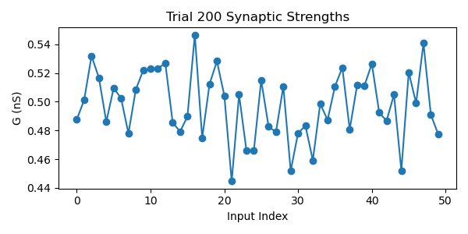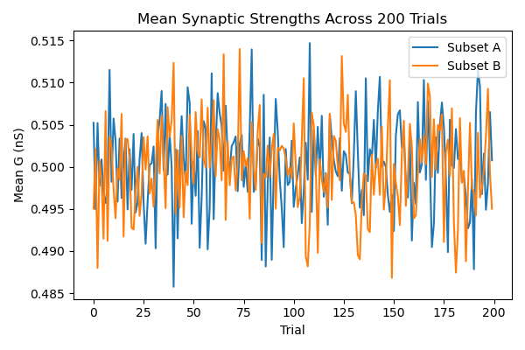

Step 5

Applied a phase-offset that alternates across trials: φa = 0 on

Added trials φ7 =+π/2 on odd trials and φb = −π/2 on even trials.

Because φ_b flips between +π/2 and –π/2 each trial, Subset B is sometimes pre-before-post (favoring LTP) and sometimes post-before-pre (favoring LTD), and Subset A (φₐ=0) likewise gets mixed timing relative to the postsynaptic spike. So adding the offset prevented the drifting which was an effect of STDP.

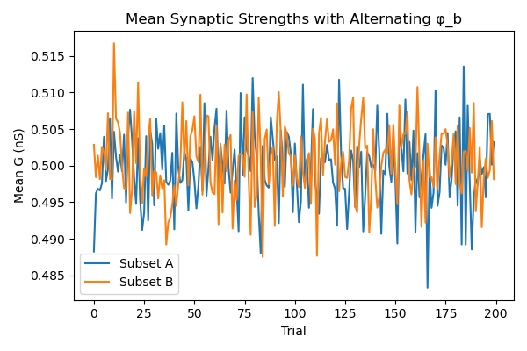

Step 6

In the first plot both blue and orange lines jitter tightly around the 0.50 nS starting point, which might suggest that with uncorrelated timing there’s no consistent pre-before-post or post-before-pre drive.

Looking at the second plot, the final synaptic strength of each neuron as a function of its phase offset: There are no clear trends. So I assume there is no systematic relationship between an input’s phase offset and its final weight when all phases are drawn independently

